

**Progress Report**

**Fall 2015-2016**

**Team Number ECE-BCC-4**

**Paintball Environment Tactical Engagement Recon System (P.E.T.E.R.S.)**

**Team Members**

|  |  |  |  |
| --- | --- | --- | --- |
| **Name** | **Department** | **Email** | |
| Richard Taylor  Anthony Schmidt  Kenneth Hale  Antonio Foster  Brett Reich | ECE  ECE  ECE  ECE  ECE | [rrt36@drexel.edu](mailto:rrt36@drexel.edu)  [ajs469@drexel.edu](mailto:ajs469@drexel.edu)  [kch44@drexel.edu](mailto:kch44@drexel.edu)  [af558@drexel.edu](mailto:af558@drexel.edu)  [br382@drexel.edu](mailto:br382@drexel.edu) | |
|  |  | |

**Team Advisor(s)**

|  |  |  |
| --- | --- | --- |
| **Name** | **Department/Company** | **Email** |
| Christopher Peters | ECE | cpeters@coe.drexel.edu |
|  |  |  |
|  |  |  |

**Group Leader's Signature :** Richard Taylor **\_\_**

**Advisor's Signature : \_\_\_\_\_\_\_\_\_**Dr. Peters **\_\_\_\_\_**

# 1. Abstract

The game of paintball has existed in one form or another for roughly the last 30 years, and in that time it has grown from a small group of friends engaging in archaic, backyard games to a full-fledged multi-million dollar-a-year industry. As a result, many great technological strides have been made in terms of improving the paintball marker, playing field, and peripheral development, but the tactics employed on the simulated battlefield and the derived annoyances that accompany them have remained largely unchanged over the years. For any seasoned paintball enthusiast, it is no secret that checking paint levels, pressurized air levels, and determining the location of teammates all involve a large diversion of attention from the task at hand and can each, in their own ways, contribute to the loss of the game. Currently, however, there is simply no work-around for keeping one’s attention totally dedicated to the game and its resulting, dynamic environment.

The *Paintball Environment Tactical Engagement Recon System* (P.E.T.E.R.S) aims to significantly lessen or totally remove these distractions by placing the required information in the peripheral vision of the user. By way of utilizing existing commercial-off-the-shelf (COTS) hardware and developing a system of network communication, this project aims to make available to the user information regarding paint level, remaining air pressure, and relative player locations in the form of a heads-up display (HUD) integrated into the paintball mask. In this way, the user can maintain a ready posture at all times in terms of directing the majority of attention to his/her surrounding environment and thereby able to react far more readily to the bevy of situations encountered during a game.

Table of Contents

[1. Abstract 2](#_Toc436034566)

[List of Figures 4](#_Toc436034567)

[2. Problem Description 5](#_Toc436034568)

[3. Proposed Work and Deliverables 7](#_Toc436034569)

[3.1 Solutions considered 7](#_Toc436034570)

[3.1.1 Hardware Considerations 7](#_Toc436034571)

[3.1.2 Software Considerations 8](#_Toc436034572)

[3.2 Unique Principles 9](#_Toc436034573)

[3.3 Existing Systems 10](#_Toc436034574)

[3.4 Criteria for Acceptable Solution 10](#_Toc436034575)

[3.5 System Flow Diagram 11](#_Toc436034576)

[4. Completed Work 12](#_Toc436034577)

[4.1 – Hardware 12](#_Toc436034578)

[4.2 – Software 13](#_Toc436034579)

[5. Work Schedule / Proposed Timeline 14](#_Toc436034580)

[6. Industrial Budget 15](#_Toc436034581)

[7. Out-of-Pocket Budget 16](#_Toc436034582)

[8. Societal, Environmental or Ethical Impacts 17](#_Toc436034583)

[9. Summary/Conclusions 18](#_Toc436034584)

[10. References 19](#_Toc436034585)

[Appendix A: Design Constraints Summary 20](#_Toc436034586)

[Appendix B: Resumes 22](#_Toc436034587)

# List of Figures

[Figure 1 – Typical Paintball Hopper 5](#_Toc436037589)

[Figure 2 – Marker-Mounted Tank Setup and Remote-Line Tank Setup 6](#_Toc436037590)

[Figure 3 – Recon Snow2 HUD 8](file:///C:\Users\afost\Dropbox\Drexel\Senior%20Design\Submissions\Progress%20Report%20Fall%202015-2016\Progress%20Report%20Fall%202015-16_FinalNoResumes.docx#_Toc436037591)

[Figure 4 – Honeywell Pressure Sensor 8](file:///C:\Users\afost\Dropbox\Drexel\Senior%20Design\Submissions\Progress%20Report%20Fall%202015-2016\Progress%20Report%20Fall%202015-16_FinalNoResumes.docx#_Toc436037592)

[Figure 5 – Laser Diodes 8](file:///C:\Users\afost\Dropbox\Drexel\Senior%20Design\Submissions\Progress%20Report%20Fall%202015-2016\Progress%20Report%20Fall%202015-16_FinalNoResumes.docx#_Toc436037593)

[Figure 6 – Overall Software Architecture Design 9](#_Toc436037594)

[Figure 7 – System Flow Diagram 11](#_Toc436037595)

[Figure 8 – Pressure Sensor Locations 12](#_Toc436037596)

[Figure 9 – Pressure Sensor Data 13](#_Toc436037597)

[Figure 10 - Project Timeline 14](file:///C:\Users\afost\Dropbox\Drexel\Senior%20Design\Submissions\Progress%20Report%20Fall%202015-2016\Progress%20Report%20Fall%202015-16_FinalNoResumes.docx#_Toc436037598)

[Figure 11 - Industrial Budget 15](file:///C:\Users\afost\Dropbox\Drexel\Senior%20Design\Submissions\Progress%20Report%20Fall%202015-2016\Progress%20Report%20Fall%202015-16_FinalNoResumes.docx#_Toc436037599)

[Figure 12 - Out-of-Pocket Budget 16](#_Toc436037600)

# 2. Problem Description

Anyone who has participated in a game of paintball understands that it is fast, chaotic, and at times incredibly intense. Paintball is designed to mimic objective-based combat scenarios with all players equipped with pressurized air-powered markers that expel paint-filled, spherical membranes designed to break on impact. As with any chaotic situation, those who are able to channel their energy and focus properly are typically the ones who succeed, and this is especially true in paintball. Any action that detracts a player’s attention away from the game, whether it is for a legitimate reason or otherwise, creates a window of opportunity, however small or large, for the opposing team to gain the upper hand by either removing players from the game or gaining a tactical advantage by gaining ground.

During a game of paintball, there are various inconveniences that arise out of the very nature of the game and the equipment used to play it. These inconveniences inevitably force the player to divert their attention away from the game. Two of these annoyances in particular involve the most vital components of the game itself: paintballs and pressurized air. More often than not, gaining “battlefield” information on these two resources involves removing oneself from the action altogether, if only for a few seconds at a time. Yet another major distraction is the constant guess-work with respect to where teammates are currently located. This is a considerable tactical disadvantage.

Throughout a typical round of paintball, a player must maintain an awareness of the amount of paintballs left in the hopper (Figure 1) and oftentimes the only way to do this is to physically lift the lid and peer inside of the loader. This involves two actions: first, the player must either alter his/her posture or move the marker out of the firing position to facilitate viewing the inside of the hopper, and second, the lid must also be lifted. Even with so-called quick-load or clear lids which essentially remove the second action, the initial action removes a player’s attention from the action unfolding around him/her.

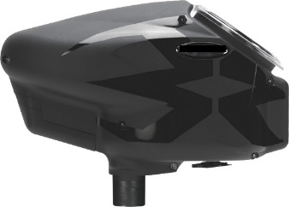

Figure – Typical Paintball Hopper

Another piece of critical information is the current level of pressurized air available to the paintball marker. This importance stems from a player’s ability to plan ahead in terms of the number of shots they have remaining based on air in the tank. Traditionally, the pressurized tank supplying the marker is connected directly to the marker itself as shown in Figure 2 (left image); in this case the tank doubles as both the air source and a buttstock of sorts to anchor the marker to the player. An increasingly larger number of players are opting for a remote-line setup as pictured in Figure 2(right image) where the tank is connected to the marker via an umbilical airline and is carried on the player’s body. The issue here is very similar to the issue presented in determining the paint level in the hopper: the player must divert attention away from the game in order to determine how much air remains in the tank. This issue is exasperated when the player is rigged into a remote-line configuration as the tank is now separated from the marker and, depending on where the tank is physically located on the player’s person, the player may require secondhand assistance to ascertain a pressure reading.

|  |
| --- |
| http://www.rap4.com/images/gen4/T68_Remote_Line_Adapter_Buttstock_Kit.jpg |

Figure – Marker-Mounted Tank Setup and Remote-Line Tank Setup

Perhaps the biggest distraction on the field for the paintball enthusiast comes from trying to determine where teammates are located. A typical snapshot during a paintball match will capture at least one player trying frantically to determine where his/her teammates are located. Traditionally, paintball players have relied on shouting back and forth, trying to get a feel for where everyone is currently positioned. The fact is that two players at opposite ends really have no idea where they are relative to one another if at all, and this can lead to tactical mistakes. The time a player takes to reacquaint him/herself with the location of teammates can very quickly turn into several seconds and result in losing situational awareness. There is a lot of effort being spent trying to ascertain very basic information, and this can create an opportunity for the opposing team to exploit.

These three issues in particular have plagued the paintball community for years, and while various tools or products have been developed and marketed to ease the impact of any one of them on the game, there is currently no product on the market that supports a solution for all three in one package. A peripheral that would consolidate all of this pertinent information into one convenient package, providing a way for players to maintain their focus on the action all around them. In this game, sustaining alertness and adapting quickly to an ever-changing environment is the key to winning, and the goal of this project is to promote the removal of significant obstacles.

# 3. Proposed Work and Deliverables

## 3.1 Solutions considered

### 3.1.1 Hardware Considerations

When the concept for P.E.T.E.R.S. was first imagined, Google Glass was thought to be the best solution for a heads up display. Google is known for putting out open source products and encourages its users to modify or “hack” them to suit their needs and share what has been accomplished with others. After Google’s release of Glass it became evident that the product didn’t resonate with the public and was quickly removed from the shelves, along with all of the support for the product. This was the deciding factor that took the product out of consideration for this project.

Needing a new solution for a HUD, Recon Instruments’ Snow2 HUD was found to be a perfect fit for the requirements of the P.E.T.E.R.S (Figure 3). This product has been created specifically for the purpose of relaying information to those participating in alpine sports. The Snow2 HUD is a module designed to function as in insert for ski/snowboard goggles which have a very similar ergonomic design with respect to paintball masks. It features a 428x240 LCD display, 9-axis sensor complement, Kalman filter algorithm-enhanced GPS networking, WiFi, Bluetooth 4.0, and has an Android operating system (OS). It is also an open-platform and has an associated software development kit (SDK) to facilitate application development.

With a HUD selected for the project, a solution to data processing and storage is next to be considered. The Raspberry Pi-2 single-board computer has been selected to function as the data and network server because it supports any language, has more than enough processing power to support the required application, is relatively low-cost, and lends itself well to any design changes that may need to be made later on in the design process.

With solutions found for storing, processing, and displaying the data, hardware was evaluated for the purpose of collecting the data. Several pressure sensors were considered to collect data on a user’s available air pressure. Eventually the Honeywell MLH05KPSL06A was chosen for its durable construction and range of operating pressure (Figure 4). For collecting data on the paint levels a player has available to them, a few solutions were proposed. One solution was to gather information on the number of paintballs entering the hopper, and to track how many paintballs were leaving the barrel through counting the number of shots fired during the course of the day. This solution proved too difficult to implement as there is no reliable way of knowing how many paintballs a player was adding to the hopper at any given time. Another solution saw to give the player the ability to “tell” the system how many paintballs he/she was adding at any given time, in conjunction with the solution above. However, this seemed like it would be a nuisance to the user, and was found to be undesirable. Finally, the solution of using a series of laser diodes and photo-resistors on the interior of the hopper to monitor the paint levels in real-time was considered (Figure 5). This eliminated the need to know how many paintballs were going into the hopper at any given time, and allowed tracking the number of shots being fired to be removed from the equation.

|  |  |  |
| --- | --- | --- |
| **C:\Users\AJ\Dropbox\Drexel\Senior Design\Images\Recon HUD_resize.jpg**  Figure – Recon Snow2 HUD | **C:\Users\AJ\Dropbox\Drexel\Senior Design\Images\PressureSensor_resize.jpg**  Figure – Honeywell Pressure Sensor | **C:\Users\AJ\Dropbox\Drexel\Senior Design\Images\Laser_resize.jpg**  Figure – Laser Diodes |

### 3.1.2 Software Considerations

In discussing the software design options that were available, it was absolutely understood that a balance must be struck between flexibility, performance, and portability. In an attempt to plan ahead with regards to possible unforeseen design flaws or other obstacles of a similar nature, the decision was made early on in the preliminary design process that the software would be written in Python. The driving reason for this is the fact that Python is an interpreted language and, as such, it can easily be ported to other devices should unforeseen issues with the current hardware suite be encountered. Third-party tools and utilities have been developed in the past few years that facilitate a much easier packaging of Python applications for usage in Android devices. Kivy is a community-driven project that has developed its own open-source Python library that facilitates GUI design which translates well to the Android platform. They have also developed a custom Android package (APK) build tool referred to as “python-for-android” which facilitates Python interpreter compilation, library inclusion, and fully-customizable distribution creation. On top of all of this, the Kivy organization provides a pre-built virtual machine archetype which is preconfigured to accommodate everything needed to create a GUI application in Python and then package it for delivery to an Android device. The Python language has a large amount of optimized and professionally authored library collections which as project development continues over the next several months will help with the more complicated coding. These characteristics of Python will hopefully lessen the time it takes to achieve a fully functioning software product.

Since facilitating the maximum amount of flexibility in terms of software is a key facet of this project, modular approach to software architecture is being stressed. This will allow greater ease in distributing portions of the overall application across a number of different hardware configurations if the need arises. Shown in Figure 6 is the overall software architecture that has been adopted and all framework has been modeled on. The main software components are the data-access layer storage (black border) which will house all data that is pertinent to the user and the system, the presentation layer display interface (green border) which will display the appropriate data for the user, the sensor data processing and updating module (blue border) which will be responsible for retrieving information from all peripheral sensors, and the external network data interface (red border) which will control communications with the other users in the field.

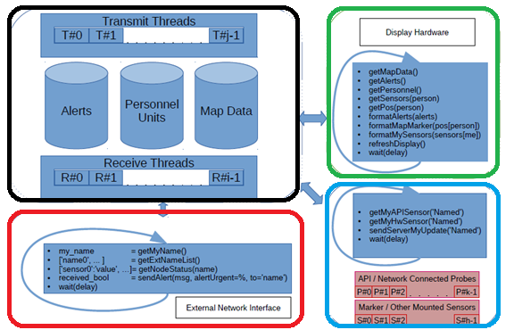

Figure –Overall Software Architecture Design

To provide a clean, uncluttered network message-passing paradigm, the usage of the JavaScript Object Notation (JSON) formatting has been adopted. This will provide uniform, straightforward network message traffic and will be utilized as the communication format between all hardware and software modules. As the JSON data formatting is language-independent, it will fit nicely with the desire to remain flexible and responsive to any design changes that may occur.

## 3.2 Unique Principles

As the Recon Snow2 HUD ships with a built in GPS, accelerometer, Bluetooth, and display screen, the amount of hardware needed to succeed is kept low and concentrated, and the project focus can be shifted to concentrate more specifically on the software needed to achieve the project’s goals. Recon Instruments provides an SDK specific to their product which allows interaction with their suite of onboard sensors. The availability of these tools from the start allows for spending far less time ensuring that accurate data is being collected and more time developing the graphical user interface (GUI) and a networking system of communication.

This particular HUD model also serves the project well in that it is designed to be glanced at for short periods of time; the emphasis is on discrete delivery of desired data to the user in an unobtrusive manner that discourages focus on the screen. This system is designed for people on the move, and as such it is designed to be situated in a person’s peripheral vision so that deliberate movement of the viewing eye is required to see the screen. As in alpine sports, a paintball player should not be forced to look at a screen at all times; a screen projected onto the inner lens of the mask itself would prove to be a large distraction when actively searching for camouflaged individuals in a wooded environment. In line with this notion, the fact that this HUD is designed to remain out of sight until needed makes it ideal compared to other display types.

## 3.3 Existing Systems

Regarding the sport of paintball specifically, there is not currently any kind of manufactured peripheral on the market that will report information to the user regarding paintball levels, pressurized air levels, and teammate location on a map. However, the Snow2 HUD itself has a similar alpine trail map and friend location feature by the use of a specific HUD app and allows third-party apps. All of the other hardware being utilized for this project include the Raspberry Pi and pressure sensors are used in many applications around the world, but there is currently no hardware/software configuration that is supporting the overall deliverables of this project.

## 3.4 Criteria for Acceptable Solution

If this to be an acceptable solution, the final product must provide the following services at a minimum:

1. Allow player to view his/her location, as well as the locations of teammates overlaid on a map of the playing field.
2. Provide the player with a visible alert that the air pressure remaining in the tank has reached a low point.
3. Provide the player with a visible alert that the amount of paintballs remaining in the hopper has reached a low point.

## 

## 3.5 System Flow Diagram

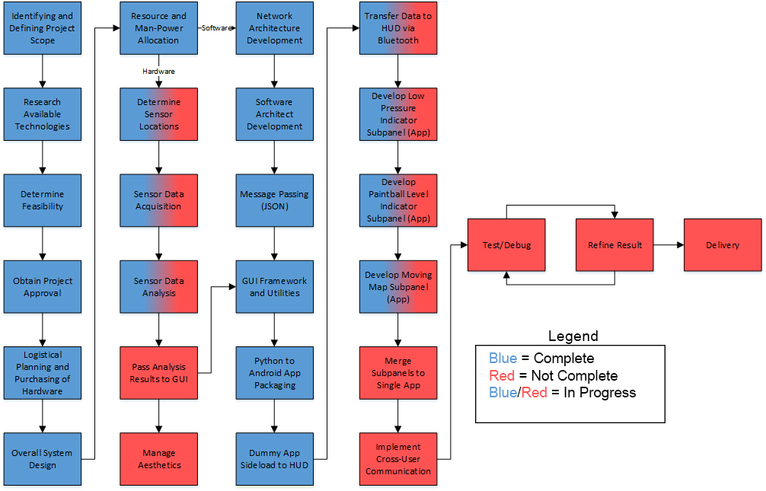

Figure – System Flow Diagram

# 4. Completed Work

## 4.1 – Hardware

There have been significant hardware mounting and sensor data accomplishments thus far. After evaluating existing paintball gear owned by team members, sensors and other testing equipment were able to be purchased. This includes the contents of the itemized budget list in section 7. The first item tested was the Honeywell pressure sensor. The sensor exists to deliver data regarding the current pressure in the air tank. Therefore, the sensor has to be mounted somewhere it can provide meaningful data. Initially, the agreed upon location for the pressure sensor was in-line with the marker’s pressure hose via a splitter (Figure 8). However, it was soon found that the pressure readings at this location were slowly declining due to a pressure regulator attached to the air tank valve. This made it difficult to derive when the tank’s air was low in order to display low pressure. After further investigation it was found that the pressure gauge affixed to the regulator could be easily removed and replaced with the Honeywell pressure sensor (Figure 8). By placing the sensor at this location a user will know the real-time pressure in the tank at any time during play as opposed to only receiving an indication when the tank’s pressure is already low. A chart of the pressure sensor readings at each location while the marker is being discharged can be seen in Figure 9.

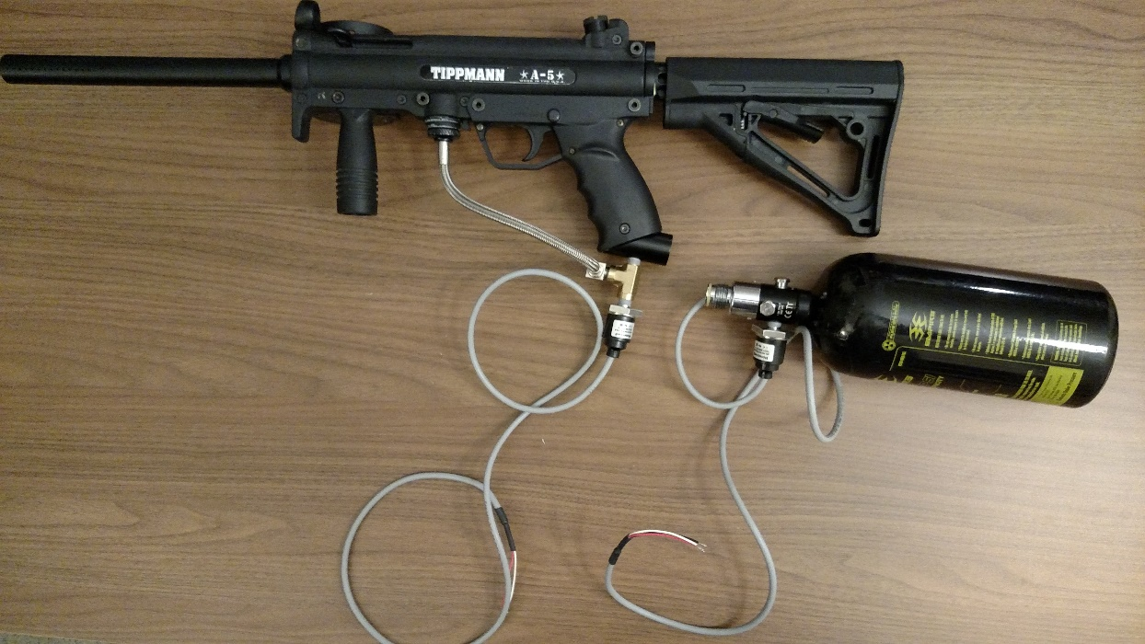

A) B)

Figure – Pressure Sensor Locations

Figure – Pressure Sensor Data

## 4.2 – Software

This past quarter has seen substantial progress in project software development. All software development has been accomplished in line with the architectural plan as pictured above in Figure 7. A basic network framework has been developed in terms of determining how communication will be achieved between the display and Raspberry Pi, the Raspberry Pi and the external sensors, and between users. In addition, it has been demonstrated successfully that JSON formatted messages can be successfully passed between modules and scrutinized according to their purpose. The framework for all required base classes for presenting desired information, displaying the map overlay, utilities for considering latitude and longitude information, and user icons has been laid is under development. A data-collecting utility has also been developed for retrieving and displaying pressure sensor analog output. For packaging Python GUIs into an APK tools from Kivy were utilized. A clear procedure was developed for creating an environment in which Python applications could be developed and subsequently packaged for Android device delivery. As a result of this, demonstrative applications completely written in Python have been visualized on the Recon HUD screen after being side-loaded via an Android Device Bridge.

# 5. Work Schedule / Proposed Timeline

Figure - Project Timeline

# 6. Industrial Budget

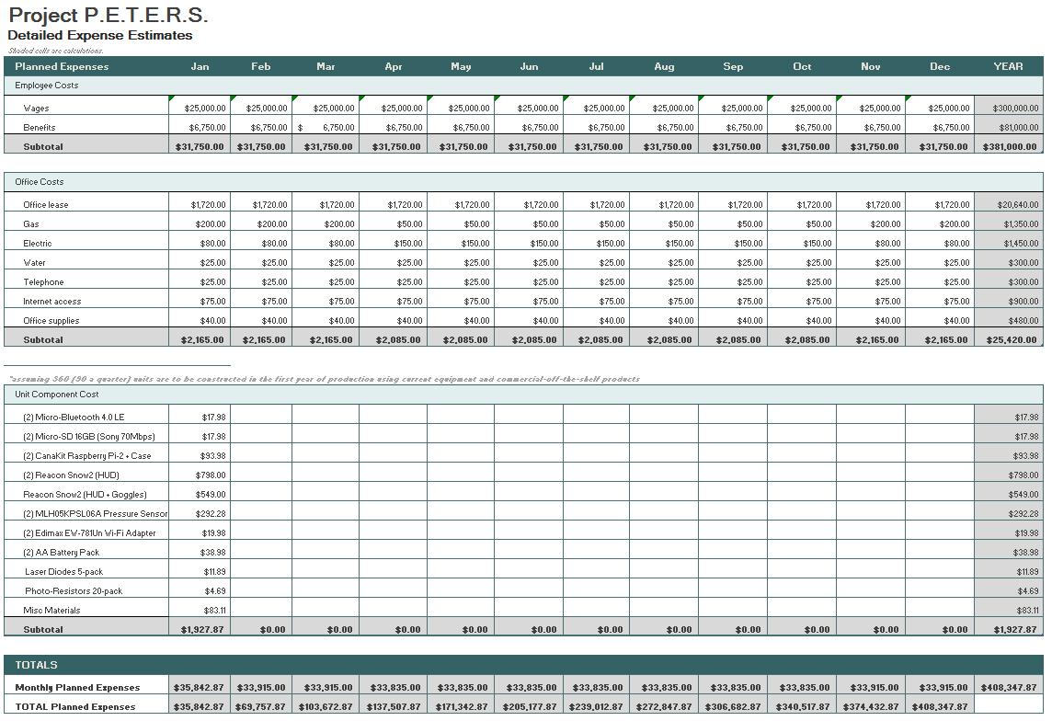

Figure - Industrial Budget

# 

# 7. Out-of-Pocket Budget

|  |  |  |  |
| --- | --- | --- | --- |
| **Model Name** | **Unit Cost** | **Units** | **Sub-total** |
| AA Battery Pack | $19.49 | 2 | $38.98 |
| Micro-Bluetooth 4.0 LE | $8.99 | 2 | $17.98 |
| Micro-SD 16GB (Sony 70Mb/s) | $8.99 | 2 | $17.98 |
| CanaKit Raspberry Pi 2 + case | $46.99 | 2 | $93.98 |
| SNOW2 (HUD only) | $399.00 | 2 | $798.00 |
| MLH05KPSL06A | $146.14 | 2 | $292.28 |
| Photo-Resistor (20pcs) | $4.69 | 1 | $4.69 |
| SNOW2 (HUD + Goggles) | $549.00 | 1 | $549.00 |
| White LED 5mm (25pcs) | $3.54 | 1 | $3.54 |
| Edimax EW-7811Un Wi-Fi Adapter | $9.99 | 2 | $19.98 |
| Female / Male / Male 1/8th | 36.47 | 1 | $36.47 |
| shipping (for goggles) | $54.99 | 1 | $54.99 |
|  |  | Total | $1,927.87 |
|  |  | Per Person | $385.57 |

Figure - Out-of-Pocket Budget

# 

# 8. Societal, Environmental or Ethical Impacts

This project is being designed with the hope of having a big societal impact. In today’s society programmers and engineers are constantly looking for an opportunity to improve the way people interact with one another. This project is another way of exploring these opportunities. The P.E.T.E.R.S. is being developed with this very idea in mind. This project hopes to enable the game of paintball in a way that brings a portion of the gaming community into the paintballing community. Part of what attracts gamers to the first-person shooter genre of gaming is the competition, the left-brain satisfying stat-tracking capabilities, and the strategic aspects of the game that make a player successful. P.E.T.E.R.S. looks to take all of these aspects and bring them to the live action of paintball. This would potentially get more people out of the house and being more active, while simultaneously drastically changing a billion dollar industry worldwide.

The ethical and environmental impacts of this project are virtually non-existent. An argument could possibly be made that the game of paintball is protecting the environment if effecting it at all. The more popular the game of paintball becomes, the more paintball playing fields that will be needed to support the growth in participants. A paintball field does not require irrigation so no water is being used for upkeep, as there is in the upkeep of a golf course. The layout of the land is generally undisturbed as well, thus preserving the habitat for any wildlife inhabiting the area.

# 9. Summary/Conclusions

The *Paintball Environment Tactical Recon Engagement System* is an important change to the popular game of paintball. By eliminating common distractions, players are able to focus more on their strategy without having to worry about their current supplies. Additionally, enabling players to see their teammates enhances gameplay further and adds a layer of tactical advantage that has been previously reserved for videogames. It should be obvious by now that implementing P.E.T.E.R.S. will be no small feat. Fortunately, a lot of the preliminary work that’s been completed has yielded positive results. The pressure sensor testing has proven that the most useful data is obtained when the sensor is directly attached to the air tank as opposed to the paintball marker. Initial testing with the laser diodes has confirmed that they will certainly be a viable solution for detecting available paintball rounds. Finally, the software progress that has been made for mapping, communications, and interfacing with the HUD has functioned as intended and provided a solid framework for the remaining software requirements. Despite the significant progress that has been made, there is a lot that still needs to be completed. This includes GUI development, tying the hardware sensors and software together, perfecting communications, and fine-tuning the final product.

# 10. References

|  |  |
| --- | --- |
| [1] | Various, "gmapcatcher," Independent, 2010. [Online]. Available: https://code.google.com/p/gmapcatcher/. [Accessed 1 October 2015]. |
| [2] | A. K. Goroch, "Algorithms for Converting Geodetic Earth Location to Satellite Time and Swath Pixel Coordinates for the DMSP Satellite System," Naval Oceanographic and Atmospheric Research Laboratory, Monteray, 1991. |
| [3] | Kivy Community Project, "Kivy Framework Reference," 2010. [Online]. Available: http://kivy.org/docs/api-kivy.html. [Accessed October 2015]. |
| [4] | Kivy Community Project, "Kivy Introduction," 2010. [Online]. Available: http://kivy.org/docs/gettingstarted/intro.html. [Accessed October 2015]. |
| [5] | A. Taylor, "python-for-android Quickstart," Kivy, 2015. [Online]. Available: http://python-for-android.readthedocs.org/en/latest/quickstart/#the-android-ndk-version. [Accessed October 2015]. |
| [6] | B. Stimac, "How To Sideload an App Onto Your Android Phone or Tablet," 17 July 2014. [Online]. Available: http://www.greenbot.com/article/2452614/how-to-sideload-an-app-onto-your-android-phone-or-tablet.html. [Accessed October 2015]. |

# Appendix A: Design Constraints Summary

Team Number: BCC - 4

Project Title: P.E.T.E.R.S.

Summary of the Design Aspects:

The P.E.T.E.R.S. will include 3 main components; the sensors, the processing hardware, and the display. The sensors will be responsible for monitoring information about the user’s location, munitions, and air pressure. This data will be relayed to the processing hardware, a Raspberry Pi, for further analysis. The results of the analysis will determine whether or not the user’s expendable resources are low and, if so, alert the user. The alert that the user receives will be via the Recon Snow2 HUD. In addition to displaying low resource indicators, the display will also show teammate’s locations. These locations will be reported via sensors and communicated to peers through wireless cards installed on the Raspberry Pi.

Design Constraints:

Economic:

This project has proven to have a rather high initial cost of design due to the use of commercial-off-the-shelf products. For proof of concept this was an acceptable scenario. If this product were to be mass produced, many of the components could be designed and developed for the intended purpose of the overall system which would save on the cost of production making it a much more likely venture for financial gain.

Manufacturability:

The design of this project is limited by the availability of tools and machinery. The main challenge is taking two components of the design that were never meant to be integrated, and integrating them. This would be easier with the proper material processing equipment or access to a wider variety of tools. In the process of building a prototype design these kinds of shortcomings are expected and are being dealt with as best as possible.

Sustainability:

This project will rely on the ability to provide power to the system for the duration of playing paintball for what could conceivably be most of the daylight hours. The power used to keep the system going must be able to handle a possible 6-8 hours of gameplay, and at the same time not be too cumbersome as to hinder the players movement around the field of play.

Environmental:

The P.E.T.E.R.S. will be have preloaded location maps for different fields of play. Therefore, the system will only work when a player is within one of these fields of play.

Ethical, health, and safety:

Users of the P.E.T.E.R.S. should be aware that staring at a small screen in close proximity to the users face could cause strain on the eyes if looked at for extended periods. It is recommended that users do not use the HUD as the main means of navigating the surrounding area. The HUD should only be used to reference oneself with their teammates, and to briefly check for available player provisions (air pressure and paint levels). Paintball is a physically demanding activity and the use of this product will in no way decrease the level of physical activity a user would exert in a day of playing paintball. All players should be aware of what playing the game entails before trying to play using the P.E.T.E.R.S., and it is not recommended that anyone attempt anything that is beyond their physical limits.

Social:

There are no immediately discernible social constraints on this project.

Political:

There are no immediately discernible political constraints on this project.

Standards and Regulations

* Standard ECMA-404 (*JSON Data Interchange Format)*
* FCC regulation Title 47 - Chapter 1 - Sub-chapter A - Part II (Frequency Allocations and Radio Treaty Matters)
* EPA regulation 40 CFR 273.13(a) (Waste management requirements for small quantity handlers of universal waste batteries)
* IEEE 1394 (IEEE USB Standard)

# 

# Appendix B: Resumes